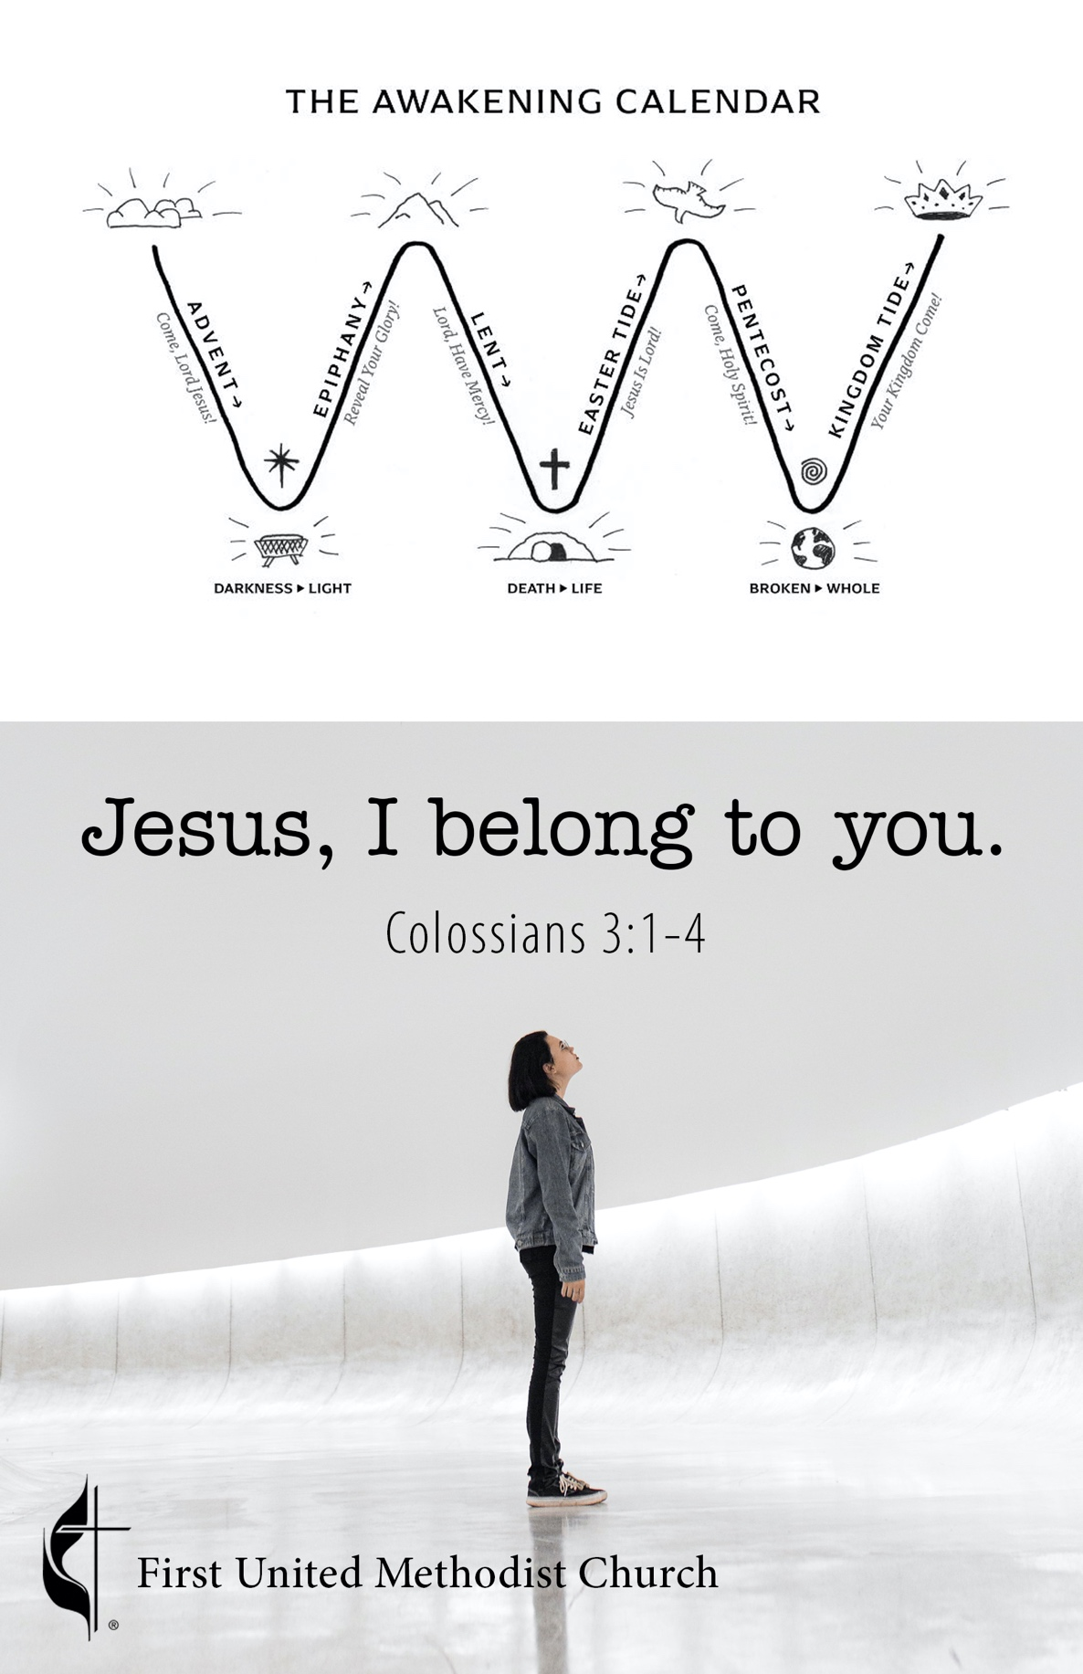**Please Remember:**

1. You may put your offering in the plate, use Tithely by scanning the QR code under Ways to Give, go directly to Tithely at https://tithe.ly/give?c=368022, or drop it off at the church office during the week or by mail.
2. You can live stream services on Facebook or YouTube at **www.facebook.com/fumcark** or **www.youtube.com/user/fumcark**. Watch previous services at **www.fumcark.org/sermons**.
3. Face masks are optional but strongly encouraged.

Arkadelphia First United Methodist Church

107 N. 9th St, Arkadelphia AR 71923 | 870.246.2493 | fumcark.org

**Senior Minister** Dr. Randy Rowlan | randy.rowlan@arumc.org

**Children/Youth Ministry** Jewelie Mills | jeweliemillsfumc@gmail.com

**Administrative Assistant** Sabrina Mecum | fumcark@gmail.com

**Treasurer** Rose Phillips | raphillips94@yahoo.com

**Technical Director** Michael Wyatt | fumcarknewsong@icloud.com

**Praise Band** Zane Hill, Ryan Lewis, Carson Lewis, Jeremy Smith,

Michelle Smith, Elizabeth Hill, and Michael Wyatt

**Tech** Mike Wyatt, Sr, Misty Smith, Emily Smith,

Annabeth Wyatt, and Hunter Wyatt

**Refreshments** Diane Wyatt

**Nursery Workers** Jewelie Mills and Erin Mecum

**Custodian** Sharon Murphy

This is a Sanctuary, a place of peace. With the exception of municipal, county, state or federal law enforcement, carrying a gun on First United Methodist Church property is prohibited. Thank you for respecting this covenant of trust.

***Adopted by First United Methodist Church Council, October 10, 2017.***

**April 24, 2022 9:00 Worship Service**

**2nd Sunday of Easter Arkadelphia, AR**

**Welcome!**

*Order of Service*

**Opening Song**…………………………………………..……..………….*Newsong Praise Band*

**Prayer of Confession & Invitation**…….……………………………..……..*Congregation*

**Announcements**………………………………………………….……….………….*Pastor* *Randy*

**Children’s Moments for Little Methodists**

**Offering**

**Pastoral Prayer**

**The Lord’s Prayer**……………………………………………………………..……..*Congregation*

**Songs of Praise**…………………...………….………………………….*Newsong Praise Band*

**Apostles’ Creed**……………….…………………………..….….…………..……..*Congregation*

**Reading God’s Word Out Loud**…………......................…… *Colossians 3:1-4, NIV*

**Sermon**………………………………………………………….…….....……..……….*Pastor* *Randy*

*Jesus, I Belong to You*

**Closing Song**………………………………………..……….…………….*Newsong Praise Band*

**Benediction/Blessing**…………………………………………………….………….*Pastor* *Randy*

***Sermon Outline***

1. **The Easter difference**
2. **The difference lies in how you see what you see**
   1. In Christ…In Colosse? Col.1:2
      1. James 4:4-6a
      2. Luke 12:15, ESV
3. **How you see, results in a better life; or not**
   1. Colossians 3:1 “Set your hearts on things above”
   2. Colossians 3:2 “Set your minds on things above”
4. **Jesus, I belong to you! (Col.3:3)**

“Will you be in the world for Christ or in Christ for the world?”

– Robert Mulholland

***Announcements***

**Wesley Foundation Fundraiser.** The Wesley Foundation is having a BBQ chicken and pork fundraiser Sunday, April 24th, at 5:00 pm at the HSU/OBU Wesley Foundation, 316 N. 11th St. There will be dessert and gospel music following the meal. Donations only.

**Discipleship Bands.** Want to know more? Meet in the Fellowship Hall at 4:00 pm with Pastor Randy.

**Youth Events.** Sunday Night Youth will be meeting in Sturgis Sunday night, April 24th, from 4-5:00 pm. We will experiment with a new game and spend some time checking in with each other and looking at how we can move closer to God. Come join us!

**Youth, Mark Your Calendars!** The Southwest District Spring Gathering will be on May 1st from 2-6:00 pm at Camp Tanako. There will be fantastic speakers, an awesome band from El Dorado, and some fun games. Dinner will be provided. We will ride in the church van together to this event. More details will be coming your way in the next couple of weeks. Please let Jewelie Mills know if you have any questions.

**Graduation Sunday.** Join us May 1st during both services as we celebrate the upcoming graduation of our high school and college graduates. We are so proud of them and their hard work and would like to show them this love as they move forward to their next steps.

**Food Pantry.** The April food distribution was very busy, our biggest distribution yet. We fed 329 families for 833 people with 366 boxes of food. The extra boxes of food were given to the 37 large families of 5 or more people. The weather was beautiful and so was the atmosphere in the Pantry. We thank you all for your support from prayers to lifting and toting, we make a village of compassionate outreach.

**The food donation request for May is** soup.

***Announcements***

**Wesley Foundation Fundraiser.** The Wesley Foundation is having a BBQ chicken and pork fundraiser Sunday, April 24th, at 5:00 pm at the HSU/OBU Wesley Foundation, 316 N. 11th St. There will be dessert and gospel music following the meal. Donations only.

**Discipleship Bands.** Want to know more? Meet in the Fellowship Hall at 4:00 pm with Pastor Randy.

**Youth Events.** Sunday Night Youth will be meeting in Sturgis Sunday night, April 24th, from 4-5:00 pm. We will experiment with a new game and spend some time checking in with each other and looking at how we can move closer to God. Come join us!

**Youth, Mark Your Calendars!** The Southwest District Spring Gathering will be on May 1st from 2-6:00 pm at Camp Tanako. There will be fantastic speakers, an awesome band from El Dorado, and some fun games. Dinner will be provided. We will ride in the church van together to this event. More details will be coming your way in the next couple of weeks. Please let Jewelie Mills know if you have any questions.

**Graduation Sunday.** Join us May 1st during both services as we celebrate the upcoming graduation of our high school and college graduates. We are so proud of them and their hard work and would like to show them this love as they move forward to their next steps.

**Food Pantry.** The April food distribution was very busy, our biggest distribution yet. We fed 329 families for 833 people with 366 boxes of food. The extra boxes of food were given to the 37 large families of 5 or more people. The weather was beautiful and so was the atmosphere in the Pantry. We thank you all for your support from prayers to lifting and toting, we make a village of compassionate outreach.

**The food donation request for May is** soup.