***Announcements***

**Wesley Foundation Fundraiser.** The Wesley Foundation is having a BBQ chicken and pork fundraiser Sunday, April 24th, at 5:00 pm at the HSU/OBU Wesley Foundation, 316 N. 11th St. There will be dessert and gospel music following the meal. Donations only.

**Discipleship Bands.** Want to know more? Meet in the Fellowship Hall at 4:00 pm with Pastor Randy.

**Youth Events.** Sunday Night Youth will be meeting in Sturgis Sunday night, April 24th, from 4-5:00 pm. We will experiment with a new game and spend some time checking in with each other and looking at how we can move closer to God. Come join us!

**Youth, Mark Your Calendars!** The Southwest District Spring Gathering will be on May 1st from 2-6:00 pm at Camp Tanako. There will be fantastic speakers, an awesome band from El Dorado, and some fun games. Dinner will be provided. We will ride in the church van together to this event. More details will be coming your way in the next couple of weeks. Please let Jewelie Mills know if you have any questions.

**Graduation Sunday.** Join us May 1st during both services as we celebrate the upcoming graduation of our high school and college graduates. We are so proud of them and their hard work and would like to show them this love as they move forward to their next steps.

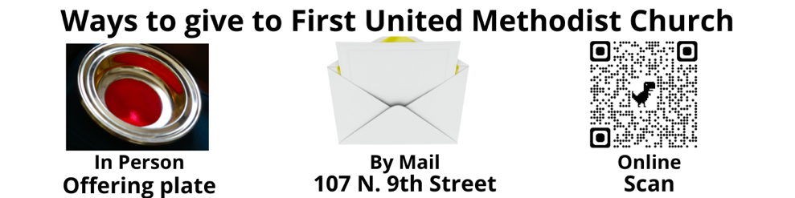

**Food Pantry.** The April food distribution was very busy, our biggest distribution yet. We fed 329 families for 833 people with 366 boxes of food. The extra boxes of food were given to the 37 large families of 5 or more people. The weather was beautiful and so was the atmosphere in the Pantry. We thank you all for your support from prayers to lifting and toting, we make a village of compassionate outreach.

This is a Sanctuary, a place of peace. With the exception of municipal, county, state or federal law enforcement, carrying a gun on First United Methodist Church property is prohibited. Thank you for respecting this covenant of trust.

***Adopted by First United Methodist Church Council, October 10, 2017.***

**The food donation request for May is** soup.

**Please Remember:**

1. 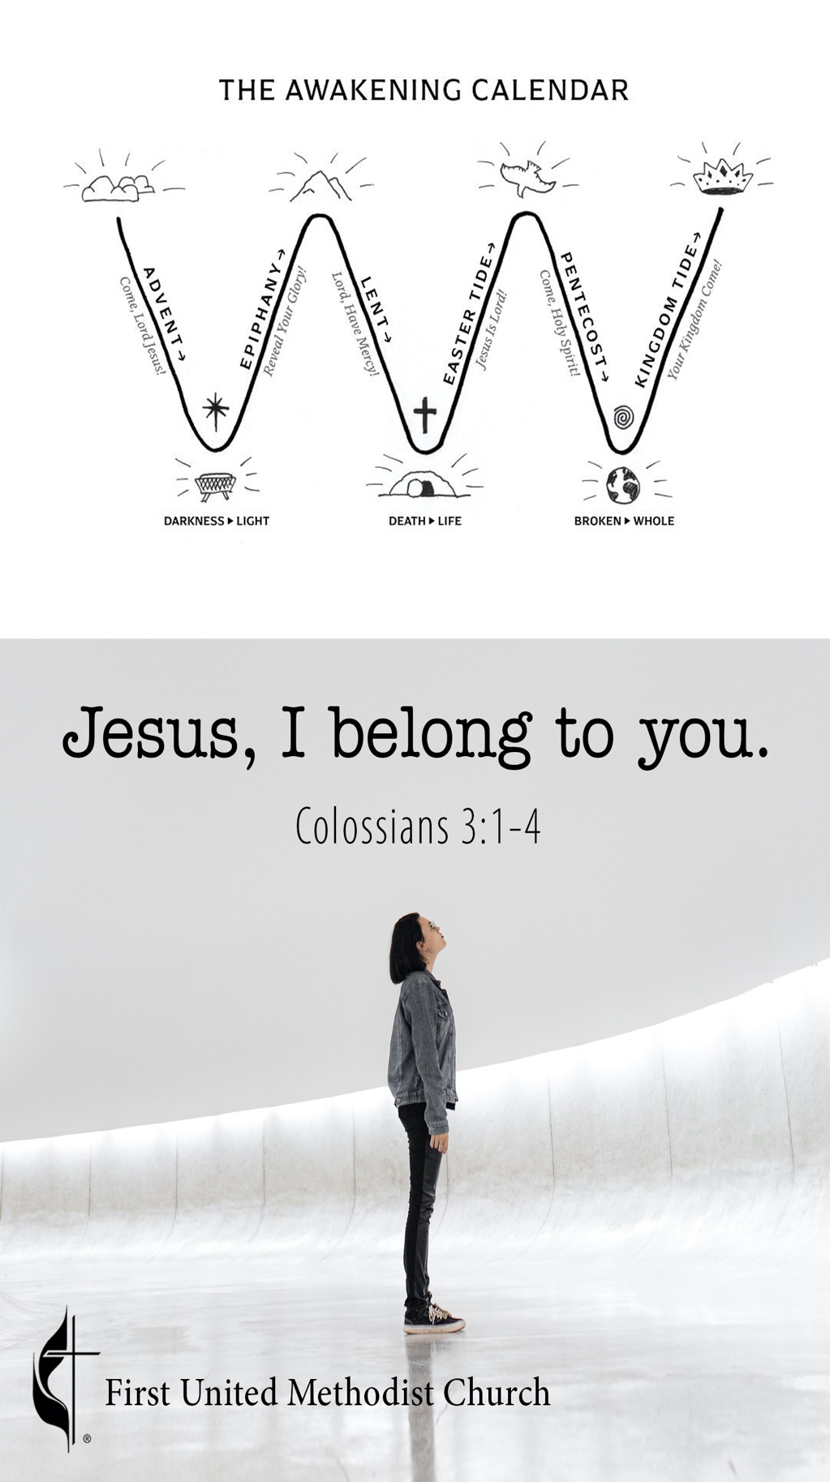You may put your offering in the plate, use Tithely by scanning the QR code under Ways to Give, go directly to Tithely at https://tithe.ly/give?c=368022, or drop it off at the church office during the week or by mail.
2. You can live stream services on Facebook or YouTube at **www.facebook.com/fumcark** or **www.youtube.com/user/fumcark**. Watch previous services at **www.fumcark.org/sermons**.
3. Face masks are optional but strongly encouraged.

Worship for the Lord’s Day

Arkadelphia First United Methodist Church

107 N. 9th St, Arkadelphia AR 71923 | 870.246.2493 | fumcark.org

**Senior Minister** Dr. Randy H. Rowlan | randy.rowlan@arumc.org

**Children/Youth Ministry** Jewelie Mills | jeweliemillsfumc@gmail.com

**Administrative Assistant** Sabrina Mecum | fumcark@gmail.com

**Treasurer** Rose Phillips | raphillips94@yahoo.com

**Technical Director** Michael Wyatt | fumcarknewsong@icloud.com

**Organist** Dr. Kay McAfee

**Choir Director** Dr. Bill Higgins

**Liturgist** Nevada Mills

**Acolytes** Reagan Mills

**Ushers** Norm Coppernoll, Bob Shehane, Eddie Graham,

Daniel Maxey, Jim Blanton, Robert McCallum

**Tech** Todd Corley, Lori Maxey, Sasha Maxey, Cindy Phillips,

Doug Sonheim, Colin Phillips

**Nursery Workers** Jewelie Mills and Erin Mecum

**Custodian** Sharon Murphy

**April 24, 2022 11:00 Worship Service**

**2nd Sunday of Easter Arkadelphia, AR**

**_________________________________________________________**

**Welcome** Nevada Mills

**Opening Voluntary** Kay McAfee

*That Easter Day with Joy so Bright*

*-by Dale Wood*

**Centering Prayer (Focus)** Pastor Randy

**\*Prayer of Confession & Invitation** Congregation

**Abba Father, we thank you for your Son, Jesus, who precedes us in the only death worth dying and in the only life worth living. Teach me the secret of dying before I die, that I might truly live while I am alive. Turn my attention from what is wrong with the world to what is wrong in my own life. Come, Holy Spirit. I want to be “in Christ,” a real Christian. We pray in Jesus’ name, amen.**

**\*Hymn of Praise** *Maker, in Whom We Live*UMH No. 88

**\*Apostles’ Creed** UMH No. 881

**\*The Gloria Patri** UMH No. 70

**Glory be to the Father and to the Son and to the Holy Ghost; as it was in the beginning, is now, and ever shall be, world without end. Amen. Amen.**

**Children’s Moments for Little Methodists**

**Pastoral Prayer and Offering**

**The Lord’s Prayer** Congregation

**The Offertory** *Easter Flowers* Kay McAfee

*-by George Blake*

**\* The Doxology**  UMH No. 95

**Praise God from whom all blessings flow; praise him, all creatures here below; praise him above, ye heavenly host; praise Father, Son, and Holy Ghost. Amen.**

**\*Reading God’s Word Responsively**

Colossians 3:1-4, NIV

*Hear the Word of the LORD*

*“Since, then, you have been raised with Christ,*

***set your hearts on things above,***

*where Christ is, seated at the right hand of God.*

***Set your minds on things above, not on earthly things.***

*For you died, and your life is now hidden with Christ in God.*

***When Christ, who is your life, appears, then you also will appear with him in glory.”***

*This is the Word of the LORD.*

***Thanks be to God.***

**Anthem**  *I Have Decided to Follow Jesus* Chancel Choir

*-arr. Wm. Reynolds*

**Sermon** *Jesus, I Belong to You*Pastor Randy

**\*Hymn** **of Response** *Christ has Risen* TFWS No. 2115

**\*Benediction/Blessing** Pastor Randy

**Closing Voluntary** *The Strife is O’er*Kay McAfee

*-by Wilbur Held*

***Sermon Outline***

1. **The Easter difference**
2. **The difference lies in how you see what you see**
   1. In Christ…In Colosse? Col.1:2
      1. James 4:4-6a
      2. Luke 12:15, ESV
3. **How you see, results in a better life; or not**
   1. Colossians 3:1 “Set your hearts on things above”
   2. Colossians 3:2 “Set your minds on things above”
4. **Jesus, I belong to you! (Col.3:3)**

“Will you be in the world for Christ or in Christ for the world?” – Robert Mulholland