News & Events
Office Closed. The church office is closed Thursday and Friday, November 24th and 25th for Thanksgiving. We reopen Monday, November 28th, at 8:00 a.m. Happy Thanksgiving!

Henderson State University Christmas Concert. HSU presents Ring Out Ye Bells Christmas concert Monday, November 28th, at 7:30 p.m. in the FUMC Sanctuary. This is open and free to the public.

United Women in Faith. UWinF has their annual Potluck Salad & Dessert Luncheon Tuesday, December 6th, 10:00 a.m., at the home of Laverne Todd. Mark your calendar and plan to bring a salad and/or dessert as well as a friend. Rev. Zeke Allen will have the devotional. We look forward to sharing a meal together.

Ruth Circle. The Ruth Circle Christmas Potluck is noon on Friday, December 16th, at the home of Sue Waymack. Barbara Rhodes has the devotional.

Lessons & Carols/Songs from the Manger. We hope you join us Sunday, December 11th, at either the 9:00 service for Songs from the Manger or at 11:00 for the 41st Annual Service of Lessons & Carols.

Weekly Participation Opportunities
Sunday Night Youth. Meets from 6-8:00 p.m. in the Sturgis Children & Youth Center. Contact Jewelie Mills for more information.

Tuesday Morning Bible Study. Meets at 9:30 a.m. in the church library. Led by Claire Gehrki (knitarkadelphia@gmail.com).

Pastor’s Bible Study. Wednesdays at noon (in person) and 6:30 p.m. (in-person/Zoom) in the Fellowship Hall. Led by Rev. Allen.
This is a Sanctuary, a place of peace. With the exception of municipal, county, state or federal law enforcement, carrying a gun on First United Methodist Church property is prohibited. Thank you for respecting this covenant of trust.

Adopted by First United Methodist Church Council, October 10, 2017.
Chancel Choir Practice. Thursdays at 6:00 p.m. in the choir room. Contact Bill Higgins (higginb@hsu.edu) for more information.

Mission Opportunities
Sock It to Me Sundays. UWinF/Ruth Circle continue to collect socks for children ages 4-8! “Sock It to Me Sundays” runs through November. There is a container in the Narthex for your donations. For more information, contact Wanda O’Quinn.

Chili for Coats. Sunday, December 4th, is the Annual Chili for Coats luncheon. A new/gently used coat or $10 will get you a chili lunch. Proceeds go to purchase coats for Clark County preshool and elementary school children. Donations gratefully accepted.

Please Remember:
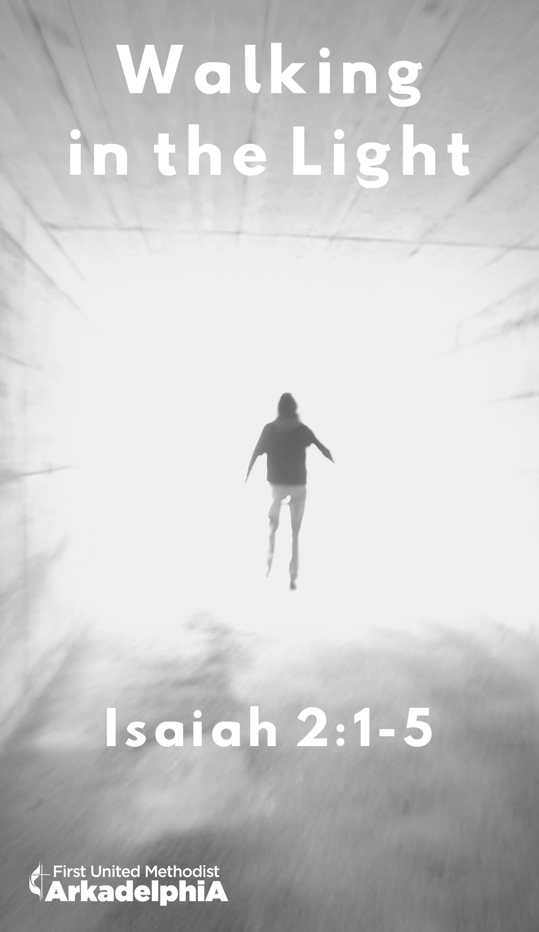
- You may put your offering in the plate, use Tithely by scanning the QR code under Ways to Give, go directly to Tithely at https://tithe.ly/give?c=368022, or drop it off at the church office during the week or by mail.
- You can live stream services on Facebook or YouTube at www.facebook.com/fumcark or www.youtube.com/user/fumcark. Watch previous services at www.fumcark.org/sermons.
Worship for the Lord’s Day
Arkadelphia First United Methodist Church
107 N. 9th St, Arkadelphia AR 71923 | 870.246.2493 | fumcark.org
Senior Minister Rev. Zeke Allen | zeke.allen@arumc.org
Children/Youth Ministry Jewelie Mills | jeweliemillsfumc@gmail.com
Administrative Assistant Sabrina Mecum | fumcark@gmail.com
Treasurer Rose Phillips | raphillips94@yahoo.com
Technical Director Michael Wyatt | fumcarknewsong@icloud.com
Organist Dr. Kay McAfee
Choir Director Dr. Bill Higgins
Liturgist Veda Goodyear
Acolytes Will Black
Ushers Norm Coppernoll, Bob Shehane, Eddie Graham,
Daniel Maxey, Jim Blanton, Robert McCallum
Tech Todd Corley, Kurt Hill, Isabela Maxey, Sasha Maxey, Cindy Phillips
Flowers Mary Ellen Taylor
Nursery Workers Erin Mecum and Sabrina Mecum
Custodian Sharon Murphy

November 20, 2022 Traditional Worship Service
First Sunday of Advent Arkadelphia, AR
________________________________________________________

Welcome Veda Goodyear

Opening Voluntary Kay McAfee
Savior of the Nations, Come
-by Frederick Frahm

*Call to Worship
Sometimes the darkness overwhelms us
The light is coming
We keep looking down, trying not to stumble and fall
The light is coming
I don’t know what to expect and feel pressure from all sides
The light is coming. Look up! Do not be afraid.
But if I look up, I might stumble. I am unsure of what is ahead.
The light is coming, do not be afraid.
Lord, where is the light?
It is here, on your path so that you won’t stumble. It is here in your heart so that you will not fear. It is here in your soul to give you hope.
Lord, help me to see and feel the presence of your light.
Behold, the light is given to all the world.

*Hymn of Praise UMH No. 211
O Come, O Come Emmanuel

*Apostles’ Creed UMH No. 881

*The Gloria Patri UMH No. 70
Glory be to the Father and to the Son and to the Holy Ghost; as it was in the beginning, is now, and ever shall be, world without end. Amen. Amen.

Lighting of the Advent Candles The Maxey Family

Children’s Moment

Pastoral Prayer Zeke Allen

The Lord’s Prayer Congregation

Hymn of Praise UMH No. 202
People Look East

Offertory Prayer Zeke Allen

Offering
The Offertory Kay McAfee
Let All Mortal Flesh Keep Silent
-by John Carter

*Doxology UMH No. 95
Praise God from whom all blessings flow; praise him, all creatures here below; praise him above, ye heavenly host; praise Father, Son, and Holy Ghost. Amen.

*Reading God’s Word Veda Goodyear
Isaiah 2:1-5

Anthem Chancel Choir
Thou Shalt Know Him
-by Mark Sirett

Sermon Zeke Allen
Walking in the Light

*Hymn of Response UMH No. 206
I Want to Walk as a Child of the Light

*Benediction/Blessing Zeke Allen

Closing Voluntary Kay McAfee
Rejoice, Rejoice Believers
-by Michael Burkhardt

*Please stand if able
ANTHEM TEXT

Thou Shalt Know Him
-by Mark Sirett

Thou shalt know Him when He comes,
not by any din of drums,

nor His manners, nor His airs,
nor by anything He wears.

Thou shalt know Him when He comes,
not by His crown or by His gown,

But His coming known
shall be by the holy harmony
which His coming makes in thee.

Amen.

